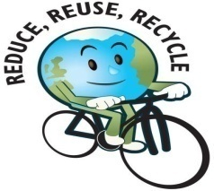

Our Eco Friendly Projects

**We are working together to :-**

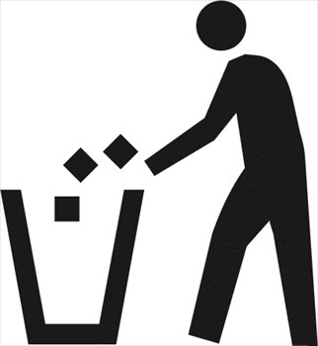**Collect litter around school** [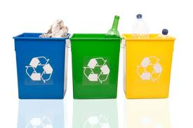](http://images.google.com/imgres?imgurl=http://www.earthsfriends.com/files/images/reduce-reuse-recycle.jpg&imgrefurl=http://ete674.gratisphphost.info/reuse-art.html%26page%3D2&usg=__SruVGndF_q55-UaEuYaNyktrt3Y=&h=283&w=424&sz=19&hl=en&start=18&zoom=1&tbnid=O35JrY30H0jhbM:&tbnh=96&tbnw=144&ei=KkliTbPhIM3sOcPm6bEN&prev=/images%3Fq%3Dreduce%2Breuse%2Brecycle%2Blogo%26hl%3Den%26biw%3D1020%26bih%3D567%26gbv%3D2%26tbs%3Disch:1&itbs=1&iact=hc&vpx=353&vpy=195&dur=1985&hovh=183&hovw=275&tx=147&ty=112&oei=_EhiTcrlHMehOtvSyM0J&page=2&ndsp=18&ved=1t:429,r:14,s:18)

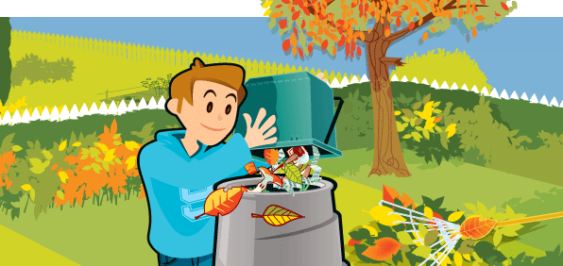[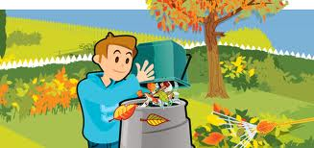](http://images.google.com/imgres?imgurl=http://www.tendringdc.gov.uk/NR/rdonlyres/9935410E-89D6-4C30-AB65-B83AF9A5EB07/0/10010_main_image_autumn.gif&imgrefurl=http://www.tendringdc.gov.uk/TendringDC/Environment/Rubbish%2BWaste%2Band%2BRecycling/HomeComposting.htm&usg=__z7h_4IYYynddsRZqG-I7c986dSQ=&h=282&w=596&sz=48&hl=en&start=183&zoom=1&tbnid=cHKEMBxKmhBzGM:&tbnh=82&tbnw=174&ei=g0xiTZ-dHorqOZCy1K4N&prev=/images%3Fq%3Dcomposting%26hl%3Den%26biw%3D1020%26bih%3D567%26gbv%3D2%26tbs%3Disch:1&itbs=1&iact=hc&vpx=462&vpy=107&dur=296&hovh=154&hovw=327&tx=125&ty=94&oei=P0xiTYLhBMuUOs-5sLMJ&page=12&ndsp=16&ved=1t:429,r:13,s:183) composting waste

**[](javascript:edit(6937))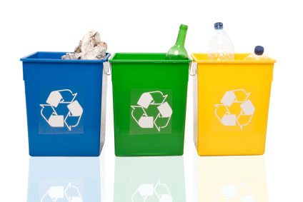Saving energy Recycling**

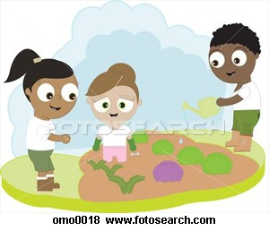**Planting Seeds**

**Plants and flowers**



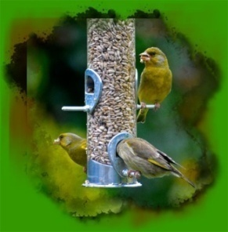**Eco Class projects**

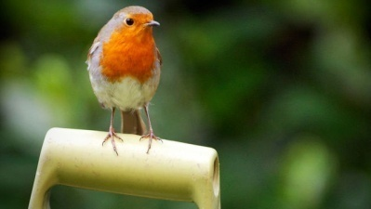Year 1 and 2

We have been watching and

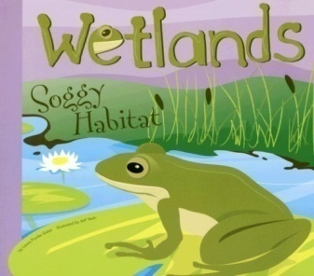Counting garden birds and making bird feeders to attract birds around the school.

Year 3 and 4

We have been learning about wetland plants, animals and their habitats. We are designing our own wetland in the school grounds.



**Year 5 and 6**

We are learning about and saving energy.

We have been looking at the amount of energy we use in school and looking at ways we can reduce this.

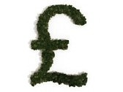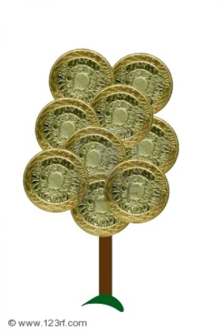

**Eco Fundraising**



Year 5 and 6 held a Fairtrade coffee afternoon for parents and carers. All the refreshments

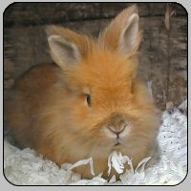were Fairtade. We raised over £50!

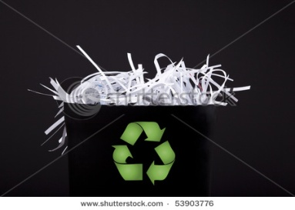

**Shredded Paper**

**We are recycling the shredded paper by selling this for just 50p a bag to use as small animal bedding.**

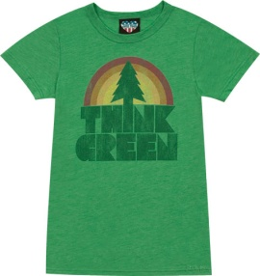

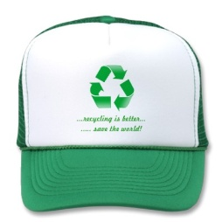 **GREEN DAY!**

**On Thursday 10th February we had green day. We came dressed in something green and donated £1 to the school Eco fund.**