Jokes
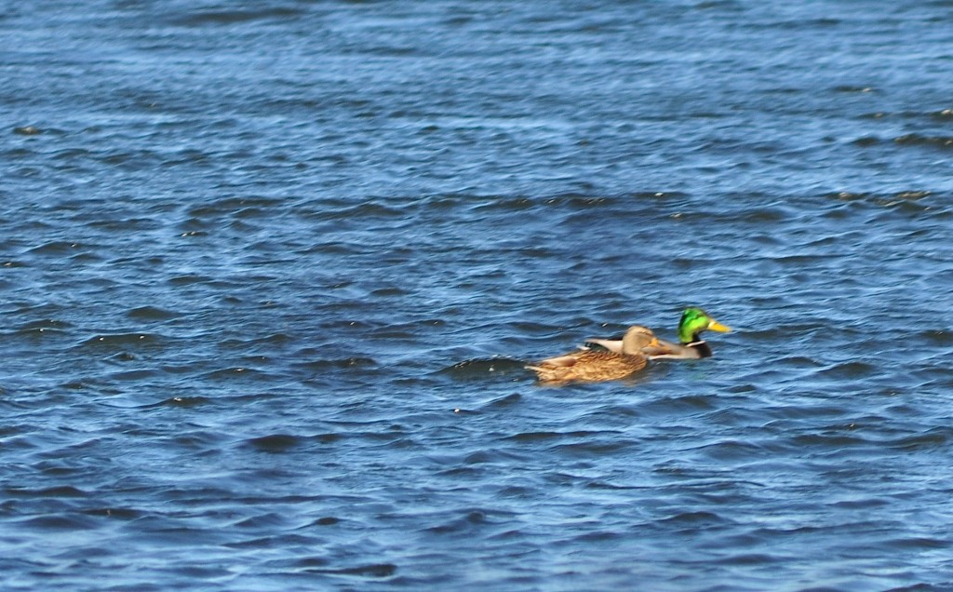
Q: What do ducks like for dinner?

A: Quackers
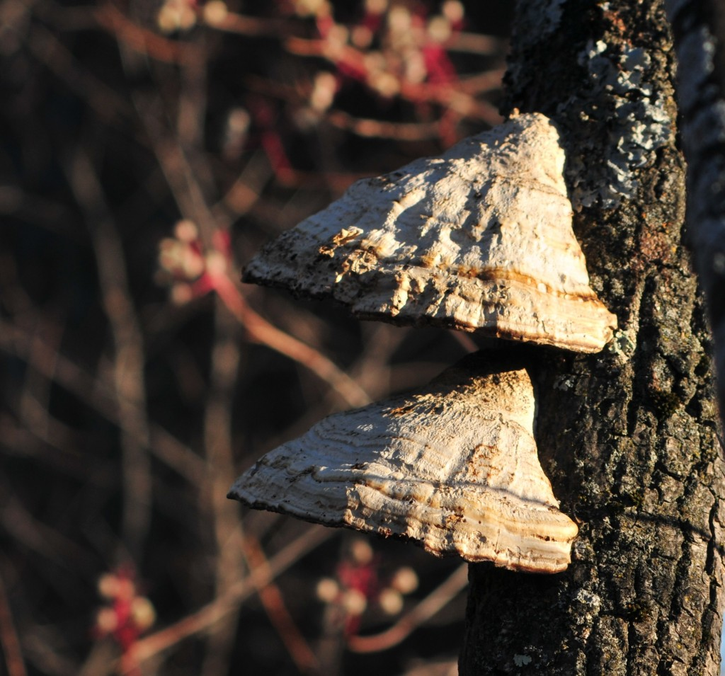
Q: What did the girl mushroom say about the boy mushroom?

A: He is a real fungi!

